Powerful Secrets of History’s Greatest Speakers
Presence, Poise, and Power to Electrify Your Talk
#3 Power Opener

- 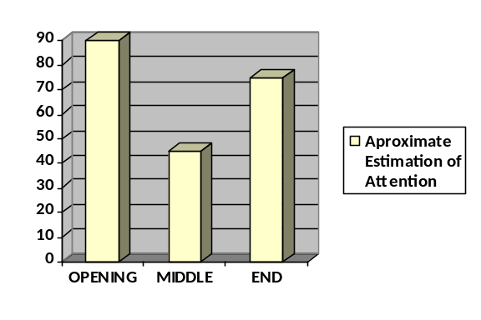The opening moments are the primetime of any talk.

“Successful persuaders open their messages powerfully, not with little ingratiating words of appreciation or praise.” –James C. Humes (author, former White House ghostwriter)

- Begin with a startling fact.

In 1875, a former slave opened his talk to the business establishment of Atlanta. Did Booker T. Washington begin by thanking his hosts for the opportunity to speak? Did he start by thanking his white hosts for extending the invitation to a black man? No, this is how he opened his talk to the southwestern United States Cotton Exposition:

Gentlemen, one-third of the population of the South is of the Negro race.

- Attention Grabbers & Audience Awakeners –Spend a lot of time preparing your opening sentence. Prepare it, Polish it, & Practice it.

Black leader, Frederick Douglas opened an address in Ohio on July 4, 1852:
Pardon me – why did you ever invite me? I and the people I represent have no reason to celebrate this day. (NOT what his audience expected!)

“If you don’t catch their attention in those first moments, the men will be daydreaming about how the Broncos will handle the Raiders, and the woman worrying about whether the roast in the oven will be done when they get home.” –Pastor John Ross, Presbyterian minister

- Begin your talk with a BANG!
Dramatic news, startling fact, surprising statement

President Roosevelt: “Yesterday, December 7, 1941—a date which will live in infamy—the United States was suddenly and deliberately attacked by the naval and air forces of the Empire of Japan.”

- Parenthetical Praise – Gratitude is taken more sincere if naturally inserted into your talk.

